


Royal County of Berkshire Pension Fund
Viewing your monthly payslip and P60 information online

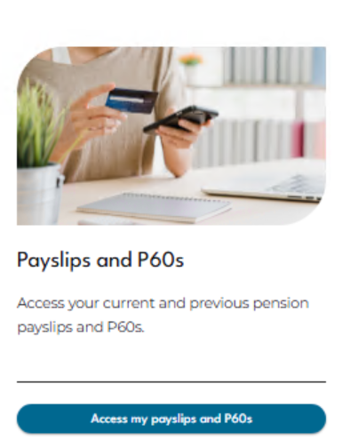
Select ‘Access my payslips and P60s’ from your Dashboard

You will be able to see a history of your pension payment periods detailing the payment date, Gross and Net pay received:
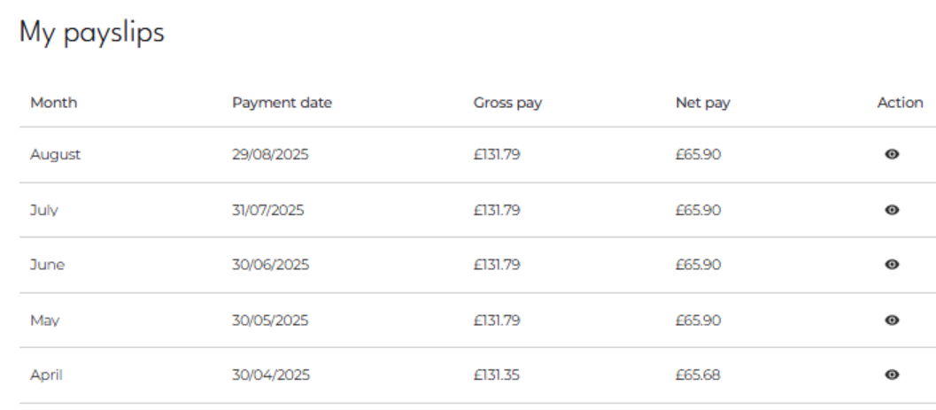


To see a more detailed breakdown of each payslip click on the eye symbol under the ‘Action’ heading:
By clicking on the eye symbol you will be able to view each payslip in more detail:

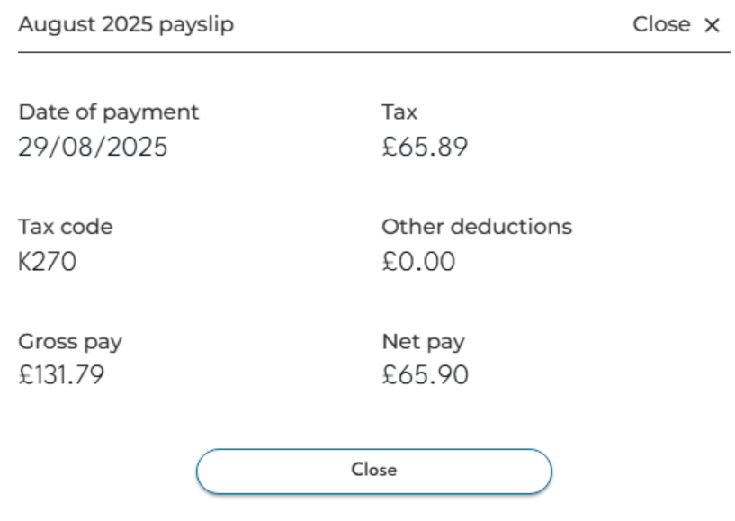
To download your monthly payslip click on the download icon:
Monthly Payslip Key
Date of Payment | This is the date your net payment credited your bank account  (if you have your pension paid into an overseas bank account it may arrive a few days after the pay date quoted)
Tax Code | The tax code we are currently operating for you. If M1 appears after your tax code, your tax code has been operated on an emergency basis. If you have a query on your tax code please contact the tax office directly on 0300 200 3300
Gross Pay | This is the total monthly pension value due to you (before tax)
Tax | The amount of any income tax deducted from your Gross pay
Other Deductions | Any other deductions which are due to be taken in addition to income tax
Net Pay | Your pay after deductions which will be credited to your bank account on your payment date
Are you in receipt of more than one pension from us? If you are receiving more than one pension, please select the drop down arrow next to your "Payroll Number" to view your payslips. If you have retired within the last month there will be no payslips to view this time. However your payslips will be displayed after your first monthly payment has been issued.

To view your P60 information navigate to the P60s tab on the Payslips and P60s page:
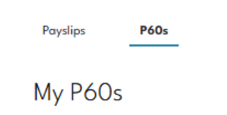

You will be presented with a list of your P60 information in respect of each tax year.

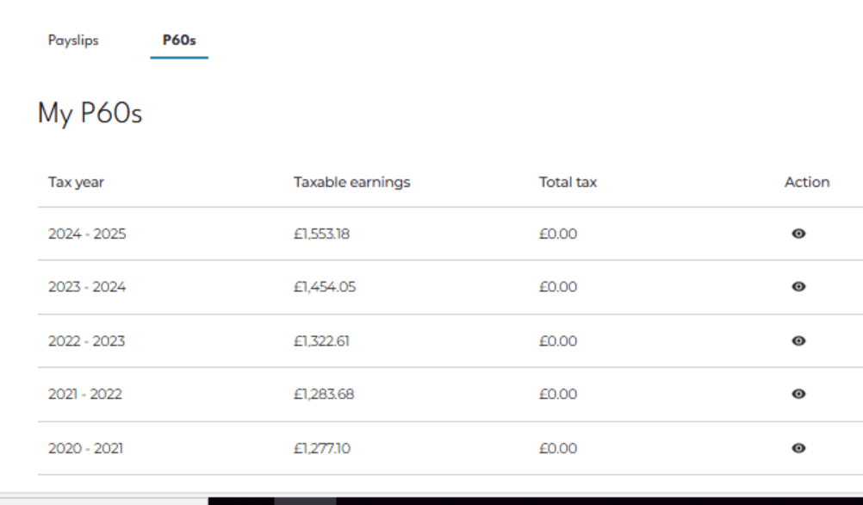

To see a more detailed breakdown of each P60 click on the eye symbol under the Action heading:
By clicking on the eye symbol you will be able to view each P60 in more detail:
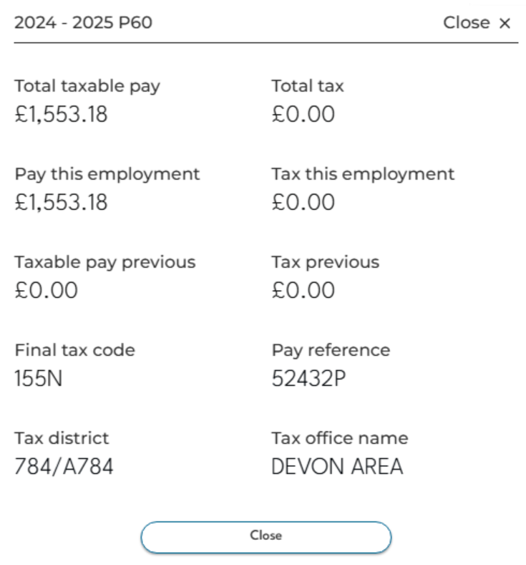

To download your P60 click on the download icon:
P60 Key
Total taxable pay | The amount of taxable pension you have received the current financial year before tax is deducted
Pay this employment | The amount of pension you have received in the current financial year before tax is deducted
Final tax code | Final tax code This is your final tax code of the year. If M1 appears after your tax code, your tax code has been operated on an emergency basis. If you have a query on your tax code please contact the tax office directly on 0300 200 3300
Tax district | This will display the tax reference number for the Berkshire Pension Fund and should be quoted if you contact HMRC
Total tax | This is the total amount of tax you have had deducted from your pension in the current financial year
Taxable pay and Tax previous | These two boxes will show any pay and tax from a previous employment in the same tax year as you left your previous job
Are you in receipt of more than one pension from us? If you are receiving more than one pension, please select the drop down arrow under your "Payroll Number " to view your P60 information. If you have retired within the current financial year there will be no P60 to view. However your P60 information will be displayed from the following April.

