


Royal County of Berkshire Pension Fund
Online Benefit Calculators Guide – Active Scheme Members
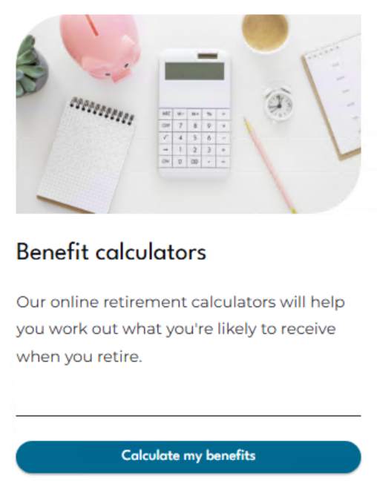
Select ‘Calculate my benefits’ from your Dashboard

You will be presented with two options:
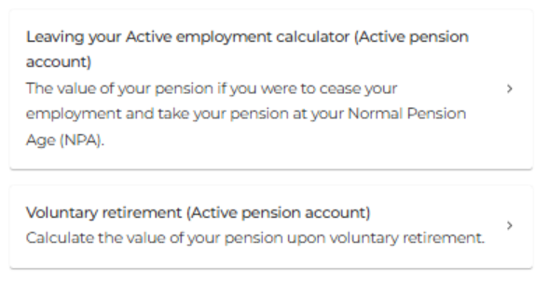

Leaving your Active employment calculator:
Leaving your job shifts your active pension to a deferred (frozen) state, still increasing in line with inflation until your retirement. Calculate its value by using our deferred benefit calculator. You have the flexibility to claim your deferred pension from age 55 (increasing to age 57 from 6 April 2028) up until the day before your 75th birthday.
This calculator shows you the value of your pension if you were to cease your employment and take your pension at your Normal Pension Age (NPA).
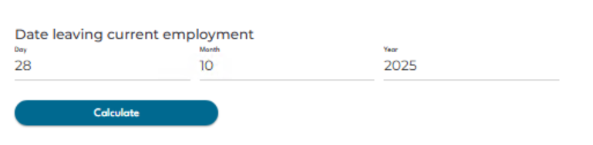
Enter a date of leaving and click the ‘Calculate’ button. Your results will be displayed below:
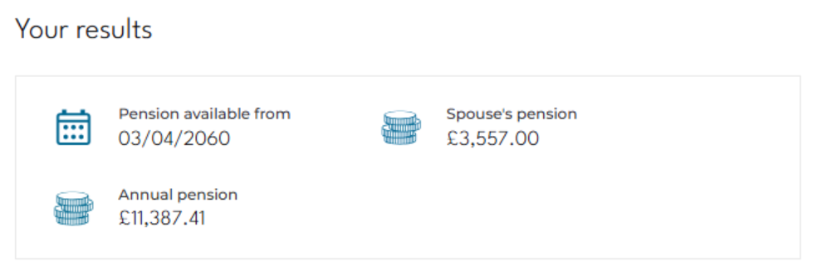
The results will display the value of your annual pension calculated to your chosen date of leaving assuming you claim your pension from your Normal Pension Age (NPA) in the future.
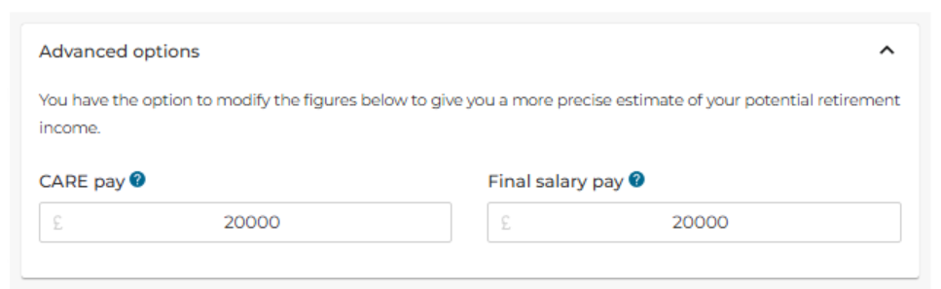
Under Advanced options you can also amend the annual pay figures we hold for you. The pay data held is provided to us by your payroll department, but you can amend these if you wish (for example if you were due to receive an increase in your salary figure).
If it is your intention to claim your Berkshire pension before your Normal Pension Age we require three months written notice. You can email your notice to info@berkshirepensions.org.uk

Voluntary retirement:
This calculator automatically sets the default date of leaving to the date before your Normal Pension Age (NPA) which is in line with your State Pension Age (SPA). You have the flexibility to retire and claim your pension from age 55 onwards (increasing to age 57 from 6 April 2028) up until the day before your 75th birthday.
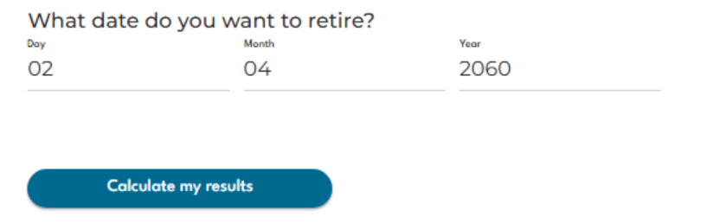
Enter the date you wish to retire.
Next check the annual salary figures you would like to use in the calculation.
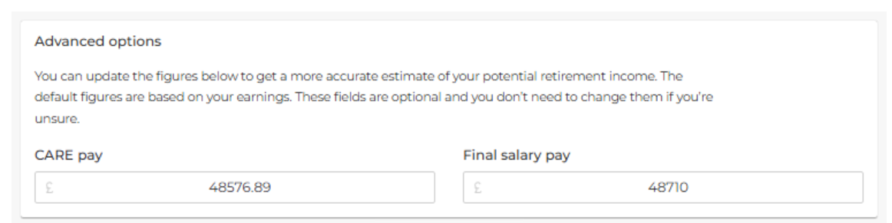
The CARE Pay and Final Pay fields will already be populated with the data held on your pension account (as provided by your employer). However, you can overtype the figures held if your pension pay has recently increased or, for example, you are due to receive a pay award/cost of living rise etc.
CARE Pay – This is the annual amount of Gross pensionable salary you receive based on your actual contracted hours and weeks.
Final Pay – This is your full-time equivalent rate of pensionable pay based on full-time hours and weeks.
Once you are happy with the date and figures held click at the ‘Calculate my results’ button and your results will be displayed below:
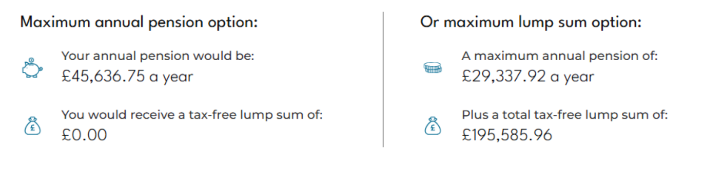

Maximum annual pension option
This option will show you the maximum annual pension you would be entitled to at your chosen retirement date.
If you have LGPS membership prior to 1 April 2008 you will have built up an automatic tax-free lump sum which will become payable at the point you retire. If you joined the LGPS after 1 April 2008 this lump sum value will show as £0.00.
Or maximum lump sum option
Under the LGPS 2014 scheme you can exchange some of your annual pension into additional tax-free cash. For every £1 of pension you give up you will receive £12 of tax-free cash (subject to HM Revenue and Customs limits). The lump sum is a tax-free payment.
The figures displayed here will show you the maximum lump sum you can have under this option and impact this would have on your annual pension income.
Personalise your pension
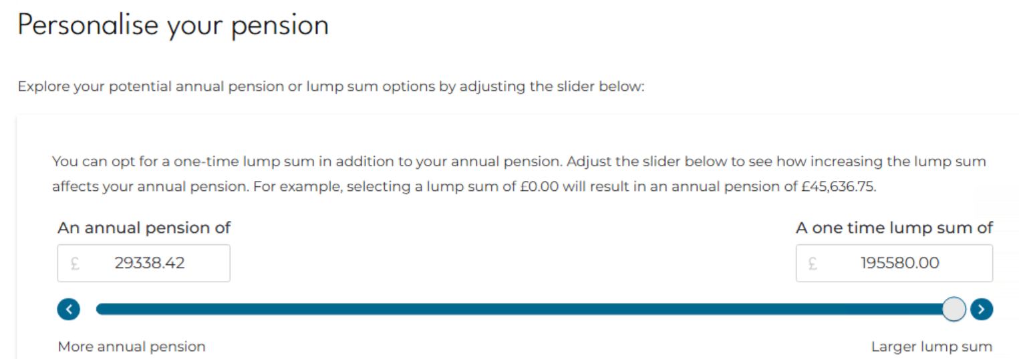
If you would like to know the maximum amount of Tax-free Lump Sum you could have you can also use the slider to view your options regarding converting Annual Pension to additional Tax-free Lump Sum.
If it is your intention to leave your employment and claim your Berkshire pension before your Normal Pension Age we require three months written notice. You can email your notice to info@berkshirepensions.org.uk
Points to note:
- The figures produced via ‘Engage’ are an estimate only and are calculated by the Royal County of Berkshire Pension Fund by reference to the relevant regulations in force at the time. If you would like any help using the benefit calculators, please contact the pension team info@berkshirepensions.org.uk
- If a divorce debit/credit exists on your pension account as a result of a Pension Sharing Order, the benefit calculators do not take this into account. Please contact the pension team directly to request an estimate of pension benefits

