
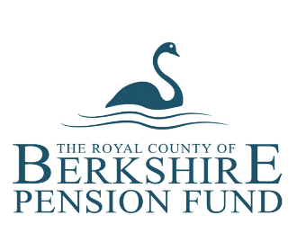

Royal County of Berkshire Pension Fund
Expression of Wish - managing your beneficiaries
A lump sum death grant is paid if, when you die, you are under age 75 and one of the following applies:
- you are still paying in to the LGPS as an active member
- you have left the LGPS but have not taken payment of your pension
- you left after 31 March 2008 and have been receiving your pension for less than 10 years
- you left the LGPS between 1 April 1998 and 31 March 2008 and have been receiving your pension for less than 5 years.
If you left before 1 April 1998 and are receiving your pension, a death grant may be paid when you die. The calculation is complex so please contact the Berkshire Pensions team directly for an estimate of the amount that may be payable.
Under scheme regulations, you are able to state who you would like to receive this benefit in the event of your death by creating an ‘Expression of Wish’ and nominating your beneficiaries.
When making your nomination you can choose one person, a number of people or even an organisation such as a charity. You can choose your husband, wife or partner, your children, any other family member or a friend, the list is endless.
Updating your beneficiaries online:
Select ‘Expression of Wish’ from your Dashboard
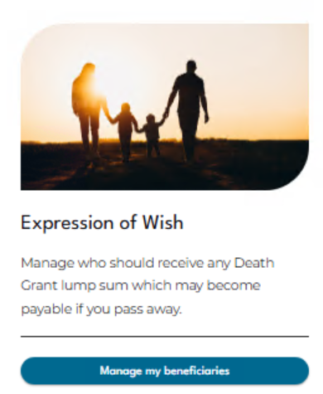

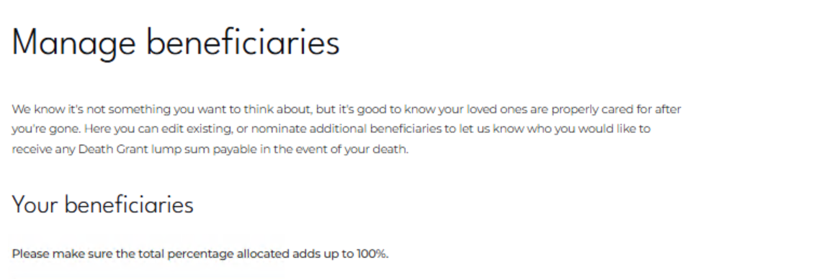
If we do not hold a nomination on file for you can ‘+Add new beneficiary’ by clicking on the button below:

Once you have clicked this button a box will expand to enable you to enter your beneficiary information:
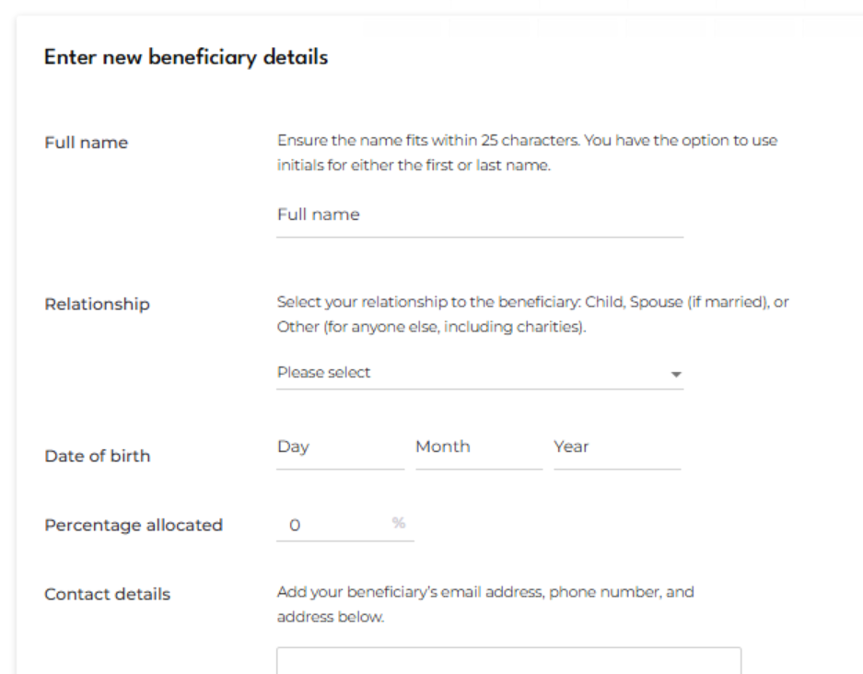

When you are happy with the information you have entered you can click the ‘Continue’ button:

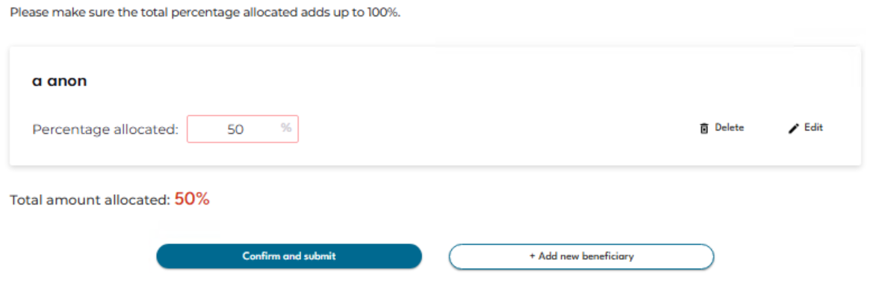
If you wish to add multiple beneficiaries, you can ‘+Add new beneficiary’ until your total percentage totals 100%.
If your total allocation is less than 100% you will see the percentage displayed in red and you will see the error message below:
Once your total percentage allocation totals 100% you will be able to ‘Confirm and submit’ your beneficiary information.
