


Royal County of Berkshire Pension Fund
Online Benefit Calculators Guide – Deferred Scheme Member

Select ‘Calculate my benefits’ from your Dashboard

You will be presented with the following option:


Deferred pension payment calculator:
Leaving your job shifts your active pension to a deferred (frozen) state. You can use this calculator to find out how much your pension would be worth if you were to take your deferred benefits into payment.

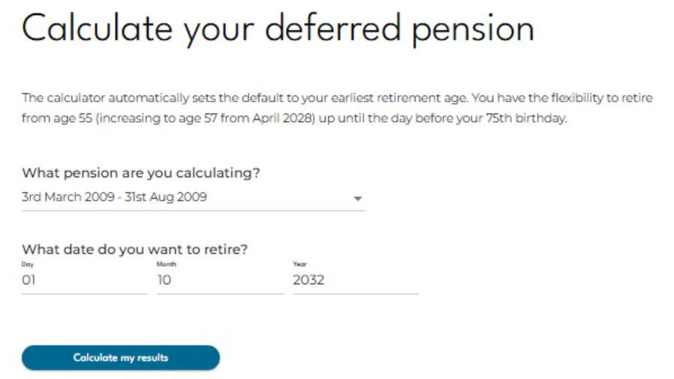

The calculator will automatically default to your earliest retirement age. You have the flexibility to claim your Deferred pension from age 55 (increasing to age 57 from April 2028) up until the date before your 75th birthday.
Enter the date you wish to retire and click ‘Calculate my results’.
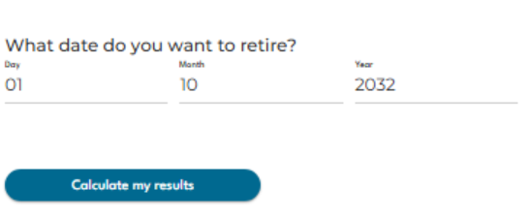

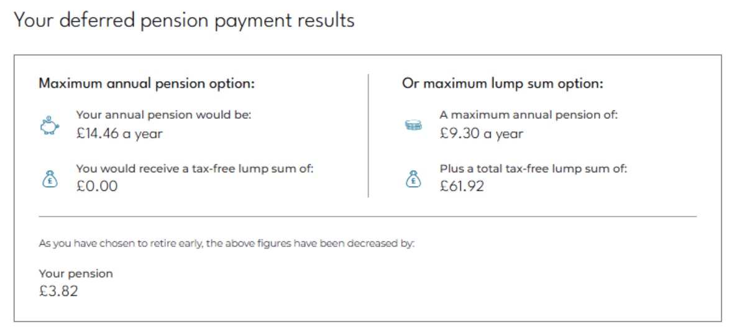
Your deferred pension payment results will be displayed for you:

Retiring before your NPA…If you have entered a payment date which is before your Normal Pension Age (NPA) the results will take into account the early retirement reduction which will be applied. The amount of reduction applied will also be highlighted in your results.
Maximum annual pension option
This option will show you the maximum annual pension you would be entitled to at your chosen retirement date.
If you have LGPS membership prior to 1 April 2008 you will have built up an automatic tax-free lump sum which will become payable at the point you retire. If you joined the LGPS after 1 April 2008 this lump sum value will show as £0.00.
Or maximum lump sum option
Under the LGPS 2014 scheme you can exchange some of your annual pension into additional tax-free cash. For every £1 of pension you give up you will receive £12 of tax-free cash (subject to HM Revenue and Customs limits). The lump sum is a tax-free payment.
The figures displayed here will show you the maximum lump sum you can have under this option and impact this would have on your annual pension income.
Important: If you ceased contributing to the scheme prior to 6 April 2006 with an entitlement to deferred benefits the method of conversion shown in the benefit calculator section may not be available to you and you should contact the pension team for further details.

Personalise your pension
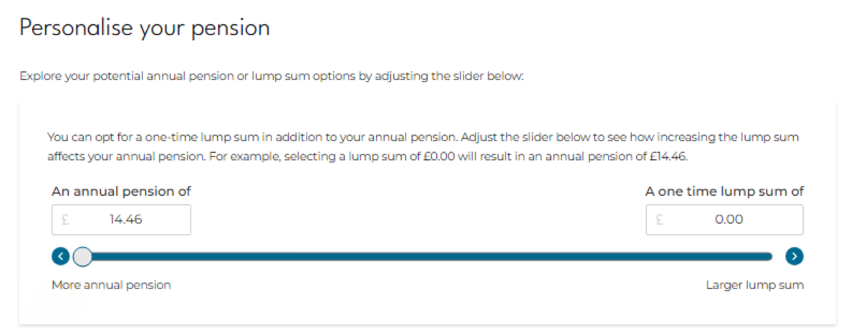
If you would like to know the maximum amount of Tax-free Lump Sum you could have you can also use the slider to view your options regarding converting Annual Pension to additional Tax-free Lump Sum.
If it is your intention to claim your Deferred pension before your Normal Pension Age we require three months written notice. You can email your notice to info@berkshirepensions.org.uk
Please note: The figures produced via ‘Engage’ are an estimate only and are calculated by the Royal County of Berkshire Pension Fund by reference to the relevant regulations in force at the time. If you would like any help using the benefit calculators, please contact the pension team info@berkshirepensions.org.uk

