# Royal County of Berkshire Pension Fund Viewing your monthly payslip online

You can view your monthly pension payslip via your online account – **‘my pension ONLINE‘**.

Your online payslip shows you how much pension has been paid and how much income tax has been deducted. You will receive your net monthly pension income from us on the last working day of the month.

**Step 1: Log in to ‘my pension ONLINE’**:   
[Welcome - Altair Member Self-Service (berkshirepensions.org.uk)](https://mypensiononline.berkshirepensions.org.uk/)   
  
(please see our [‘my pension ONLINE’ registration factsheet](https://www.berkshirepensions.org.uk/sites/default/files/2025-02/bpf_my_pension_online_factsheet.docx) if you require help registering or logging on).

**Step 2:** 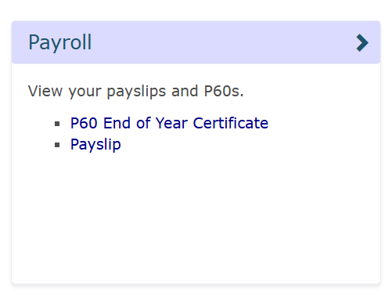Select **‘Payslip’** from the ‘**Payroll**’ section of your home page/dashboard.

You will be presented with your **‘Year to Date’** figures at the top of the screen. Your ‘Year to Date’ figures show the amount of Gross pension you have received since April up to date along with any income tax you have paid:

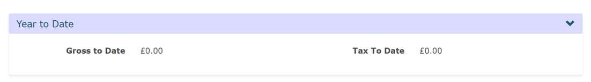

Below this you will see the history of your pension payment periods detailing the payment date and Net pension received:

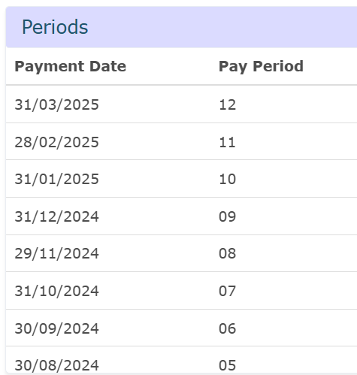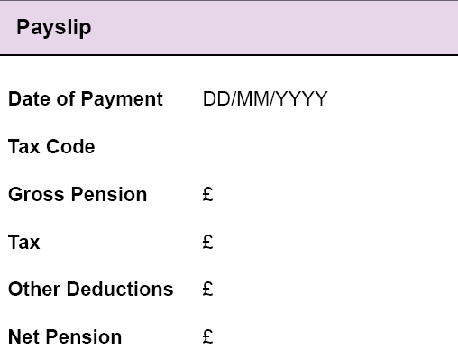

Payslip

Periods

**Step 3:** To view a specific pension payment in more detail simply click on the payment you would like to view and a detailed payment slip will be displayed on the right hand side of the screen.

|  |  |
| --- | --- |
| **Date of Payment** | This is the date your net payment credits your bank account (if you have your pension paid into an overseas bank account it may arrive a few days after the pay date quoted) |
| **Tax Code** | The tax code we are currently operating for you. If **M1** appears after your tax code, your tax code has been operated on an emergency basis. If you have a query on your tax code please contact the tax office directly on **0300 200 3300** |
| **Gross Pension** | This is the total monthly pension value due to you (before tax) |
| **Tax** | The amount of any income tax deducted from your Gross pay |
| **Other Deductions** | Any other deductions which are due to be taken in addition to income tax |
| **Net Pension** | Your pay after deductions which will be credited to your bank account on your payment date |

# Multiple Pension Accounts

If you have other pension accounts with us in addition to your retired member account (for example an active or deferred pension) you can navigate between your accounts using the green dropdown arrow located in the top tight hand corner of your dashboard homepage:



If you have more than one pension in payment with us your monthly payslips will only show on one of your pension accounts.

# Contact us

If you would like help viewing your payslip details online or you have a specific query relating to your monthly pension payment please contact the payroll team on 01628 796 670 or e-mail [info@berkshirepensions.org.uk](mailto:info@berkshirepensions.org.uk)

If you are calling from abroad please use +44 1628 796 670

If you have any general LGPS queries please contact our helpdesk on 01628 796 668