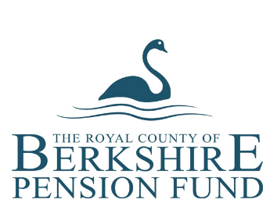
McCloud: Public service pensions history form
Please read the notes overleaf carefully before completing this form
 | PART 1: Member’s personal information
 | Name |  | NI number
 | Email address |  | Date of birth
 | Home address

 | PART 2: Previous pension scheme membership
 | Scheme name* | Reference / plan number | Date from and to | Contributions refunded?
 |  |  |  | YES |  | NO
 |  |  |  | YES |  | NO
 |  |  |  | YES |  | NO
 |  |  |  | YES |  | NO
 | * If you were a member of the LGPS, Firefighters’ Pension Scheme or Police Pension Scheme, please include the name of the relevant LGPS Pension Fund, Fire and Rescue Authority or Police Authority

 | PART 3: Declaration
 | I give my consent for the Berkshire Pension Fund to get information about previous pension scheme membership from the schemes named above.
 | Signature |  | Date
 | Please complete the sections below if you are completing this form on behalf of a member who has died
 | Your name |  | Relationship to member
 | Your email address
 | Your home address

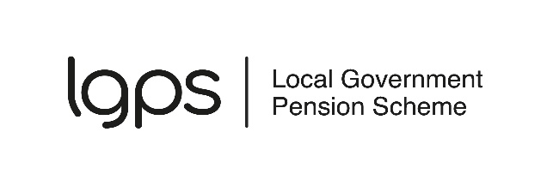
McCloud: Public service pensions history: Notes for members

What is the form for?
Some LGPS members are protected by the McCloud remedy. You can find out more about the McCloud remedy on the website for LGPS members:
www.lgpsmember.org/mccloud
Protection depends on when you were a member of the LGPS and any other public service pension scheme. Use this form to let the Berkshire Pension Fund know about any other relevant pension scheme membership.

What is a public service pension scheme?
A public service pension scheme is a UK pension scheme for:
- civil servants
- the judiciary
- the armed forces
- local government workers
- teachers
- fire and rescue workers
- members of the police force.

Do I need to fill in the form?
You only need to fill in the form if you were a member of a public service pension scheme before you joined the LGPS in the Berkshire Pension Fund. Not everyone in this group will need to complete the form. You do not need to complete the form if:
- the only public service pension scheme you have been a member of is the LGPS in the Berkshire Pension Fund
- you were a member of a public service pension scheme before you joined the LGPS in the Berkshire Pension Fund, but that membership has been transferred to the Berkshire Pension Fund
- you first joined a public service pension scheme after 31 March 2012
- you left the LGPS or reached age 65 before 1 April 2014 [2015 in Scotland]
- you are/were a councillor member in the Berkshire Pension Fund [England and Wales only]
- you joined the LGPS with the Berkshire Pension Fund after 31 March 2022
- you joined the LGPS with the Berkshire Pension Fund before 1 April 2012 and had no long gaps (over five years) in membership.

What do I need to include in the form?
You do not need to tell us about:
- membership of a public service pension scheme after you left the Berkshire Pension Fund (you might need to complete a form like this for the scheme you joined later)
- membership of a public service pension scheme that ended before 1 April 2007
- a survivor pension you are receiving from a public service pension scheme – but see the last section of these notes if you are receiving a survivor pension from the LGPS
- a pension credit in a public service pension scheme – this is a benefit awarded to you as part of a pension share following a divorce or dissolution of a civil partnership.

What happens next?
We will use the information you provide to find out whether you are protected by the McCloud remedy. We may need to ask for more information from your previous pension administrator.
Active and deferred members: If you are protected, we aim to include an estimate of what this means for your pension in your next annual benefit statement. We will take account of your protection in other figures we produce for you, such as retirement estimates.
Pensioner members: If you are protected, we will review your pension. If it increases, we will tell you in writing the new amount and any arrears and interest we are paying. Most pensions will not increase. This is because the pension that members built up in the career average scheme is more than they would have built up in the final salary scheme.
Other members: If you transferred your LGPS pension to a different scheme, you could be affected by McCloud protection. Complete the form if you think this might apply to you.

Pension transfers
This is not the form to use to request a transfer of previous pension rights. If you joined the LGPS less than a year ago, you can request a pension transfer by completing a transfer in form https://www.berkshirepensions.org.uk/members/active-members/new-starter-information
A transfer is not usually possible after your first year of membership. Your employer may allow a late transfer in exceptional circumstances. Contact your employer’s HR department for more information on how to apply for a late transfer.

Completing the form after a member has died
The McCloud remedy could affect payments made in respect of an LGPS member who has died. This includes member pension payments, death grant, survivor pension payments paid to a spouse, partner or children, or a past transfer value.
If you are completing the form on behalf of a member who has died, please complete parts 1 and 2 with the member’s details and include your details in part 3.

