Royal County of Berkshire Pension Fund

How to perform benefit calculations

Did you know you can calculate your own pension estimates through ‘my pension ONLINE’?
You can calculate as many estimates as you wish by using our online portal. Follow these step-by-step instructions to find out how:
Log onto ‘my pension ONLINE’: Welcome - Altair Member Self-Service (berkshirepensions.org.uk)
(please see our my pension ONLINE factsheet if you require help with logging on).
- Simply log on to ‘my pension ONLINE’ and select ‘Benefit projectors’ from the ‘Pension Benefits’ section of your home page/dashboard.
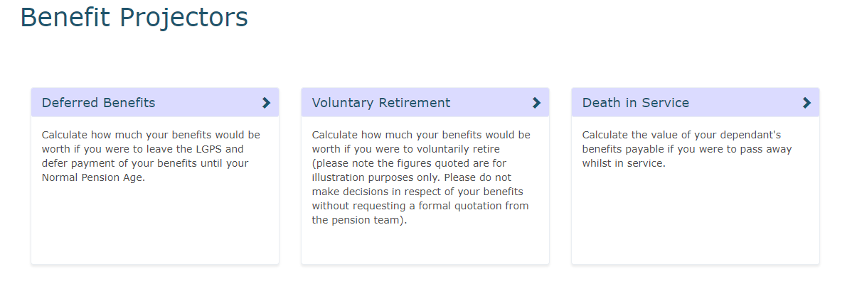
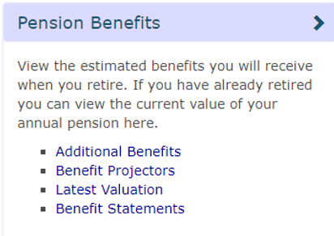

- Select ‘Voluntary Retirement’ option to calculate your pension assuming you were to work until a particular date and claim your pension benefits.
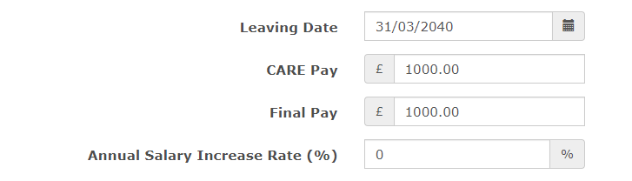
- Choose the ‘Leaving Date’ you would like to use in the calculation. This is the date you would like to retire and receive immediate payment of your pension benefits (input any date from age 55 onwards).

- Next check the annual salary figures you would like to use in the calculation.
The CARE Pay and Final Pay fields will already be populated with the data held on your pension account (as provided by your employer). However, you can overtype the figures held if your pension pay has recently increased or, for example, you are due to receive a pay award/cost of living rise etc.
CARE Pay – This is the annual amount of pensionable salary you receive based on your actual contracted hours and weeks.
Final Pay – This is your full-time equivalent rate of pensionable pay based on full-time hours and weeks.
Once you are happy with the date and figures held click at the bottom of the page.
Your estimated figures will be displayed at the top of the page:
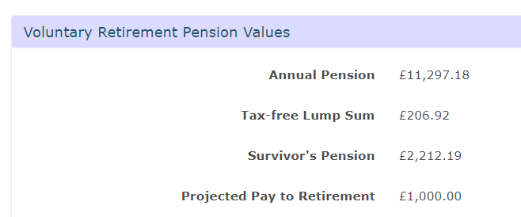
Annual Pension: Pre-tax income you will receive on an annual basis (paid monthly).
Tax-free Lump Sum: If you have LGPS membership prior to 1 April 2008 you will have built up an automatic Tax-free Lump Sum which will become payable at the point you retire. Under the LGPS 2014 scheme you can exchange some of your Annual Pension for additional tax-free cash. For every £1 of Annual Pension, you give up you will receive £12 of tax-free cash (subject to HM Revenue and Customs limits). The Lump Sum is a tax-free payment.
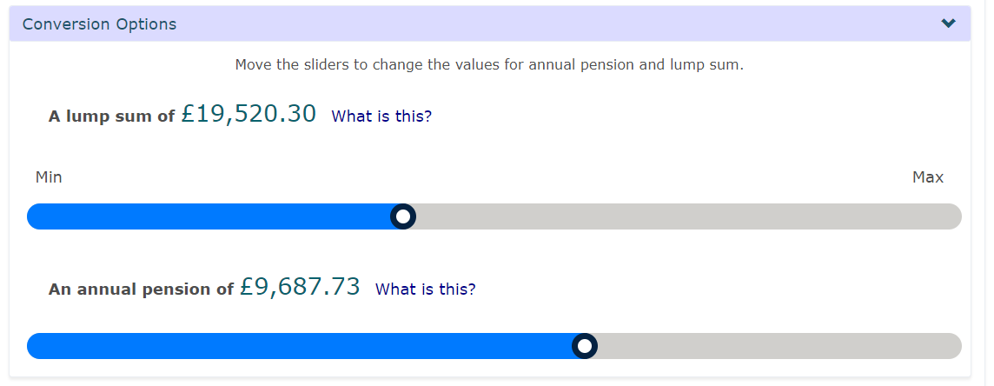
- If you would like to know the maximum amount of Tax-free Lump Sum you could have, under the ‘Conversion Options’ you can also use the slider to view your options regarding converting Annual Pension to additional Tax-free Lump Sum.

When you’ve amended as applicable, select

Please note: The figures produced via ‘my pension ONLINE’ are an estimate only and are calculated by the Royal County of Berkshire Pension Fund by reference to the relevant regulations in force at the time. They are an estimate only and actual details will be confirmed on notification from your employer on ceasing employment.
If you would like any help using the benefit calculator a member of the pension team will be more than happy to go through this with you and provide assistance. Please contact the pension team on 01628 796 668 or e-mail info@berkshirepensions.org.uk

