Royal County of Berkshire Pension Fund

‘my pension ONLINE’

Take control of your pension…

What is ‘my pension ONLINE’ ?

‘my pension ONLINE’ is an internet-based application which enables you to securely access and update your own pension details online via the Royal County of Berkshire Pension Fund website from the comfort of your own home or workplace, using your desktop PC, laptop, smart phone or tablet.

As an Active or Deferred (former) member of the scheme you can:

- view your personal details
- update your home address
- perform benefit calculations
- create or update your Death Grant ‘Expression of Wish’
- access all publications such as your Annual Benefit Statements, Scheme factsheets and newsletters

As a Retired member of the scheme, you can:

- view your personal details
- update your home address
- view your P60 and payslip history
- access all publications and newsletters
- calculate the value of your dependant benefits

How do I register?

- To begin your registration, follow the link to the ‘my pension ONLINE’ homepage. Visit www.berkshirepensions.org.uk and click on the ‘my pension ONLINE’ logo.

- On the ‘my pension ONLINE’ information page, click on the ‘Register’ option

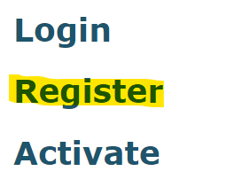

- You will be presented with ‘Terms and Conditions of use’. Once you have read these and you are happy to proceed click: ‘I agree to the above Terms and Conditions’. From here you will be directed to the homepage of the ‘my pension ONLINE’ portal:

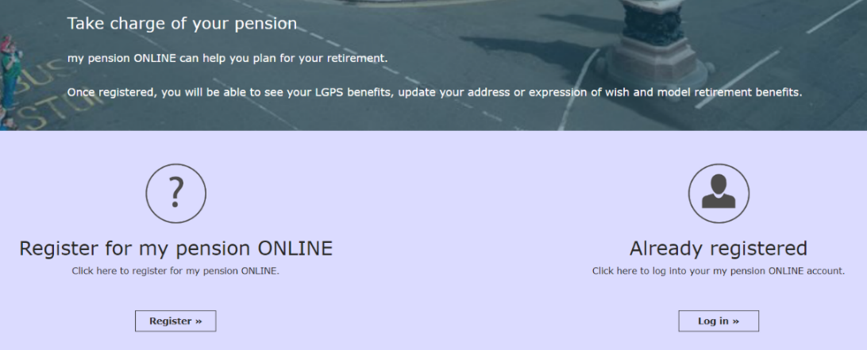

- From the ‘my pension ONLINE’ homepage click on ‘Register’. You will be directed to the ‘Sign Up’ page.
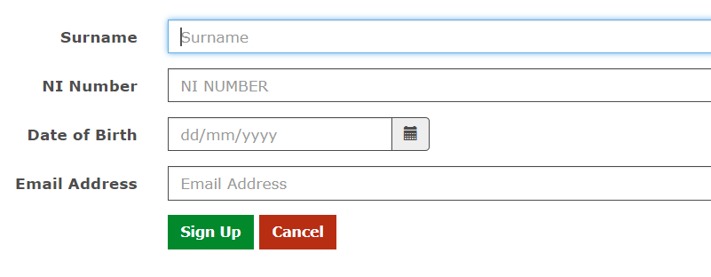

- Enter your Surname and NI Number using capital letters only and your Date of Birth using the format dd/mm/yyyy. Enter your E-mail Address and click to permit the generation of an activation link.

- If we already hold an e-mail address on your pension file, you will receive an automated e-mail containing an activation link.

If we do not have an e-mail address already on file for you a member of the pension team will send a link via e-mail to you under separate cover.

- Click on the link contained in your e-mail and you will be directed to the Registration page:
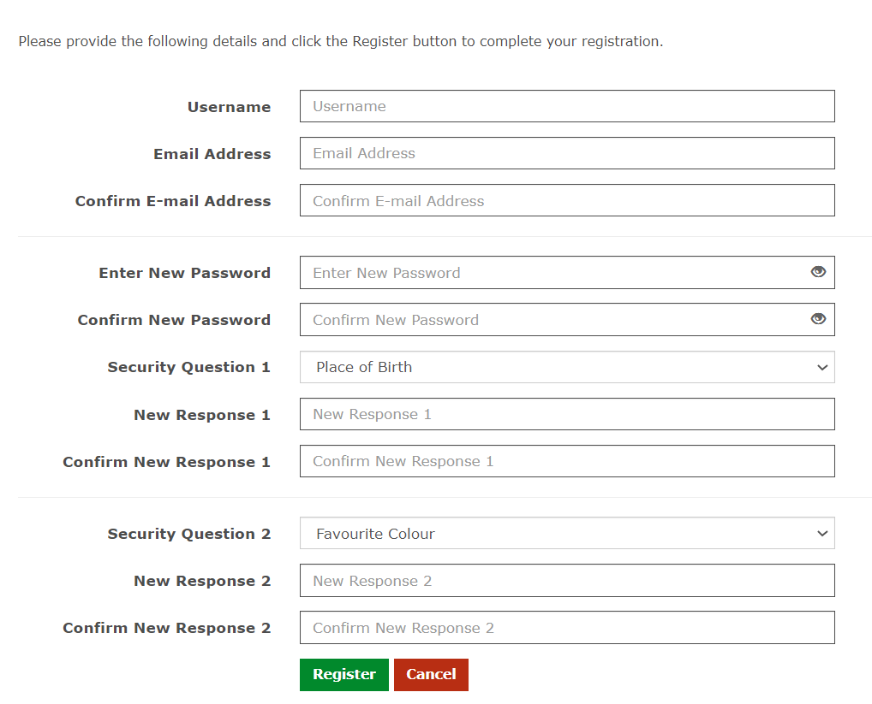

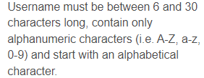

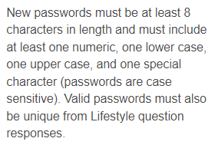

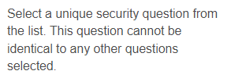

Click to confirm your registration details.

You are now signed up to ‘my pension ONLINE’. Don’t forget to add ‘my pension ONLINE’ to your browser favourites.

- When you login you will be presented with your Dashboard:
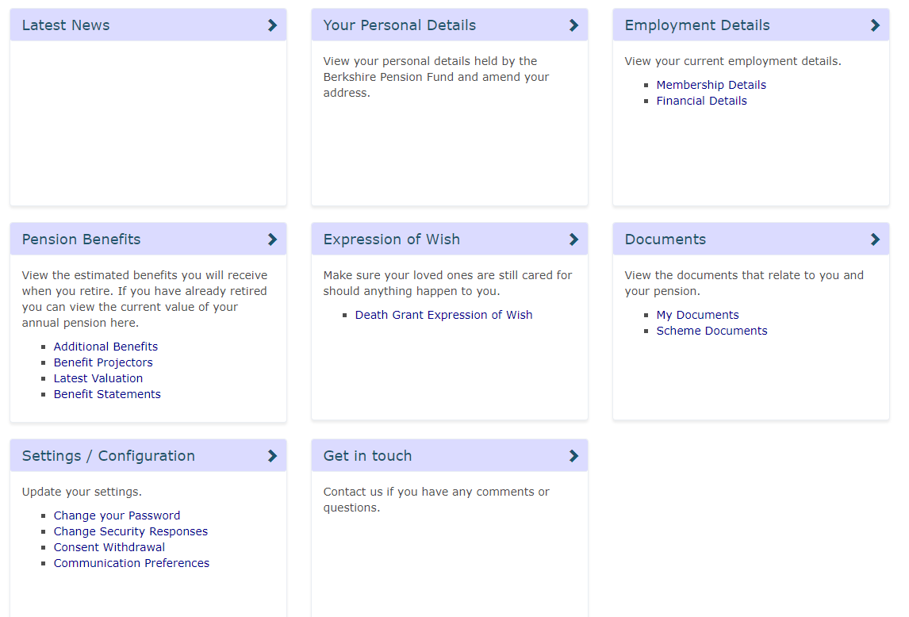

- If you have more than one pension account with the Royal County of Berkshire Pension Fund you will see a green drop-down box in the top right-hand corner of your Dashboard. This will enable you to switch between your pension accounts.

If you are a new starter…

If you have recently commenced membership of the Local Government Pension Scheme administered by the Royal County of Berkshire Pension Fund you will receive a welcome letter from the pension team containing an activation code. This code will be valid for 90 calendar days.

To activate your online account visit www.berkshirepensions.org.uk and click on the ‘my pension ONLINE’ logo.

- On the ‘my pension ONLINE’ information page click on the ‘Activate’ option

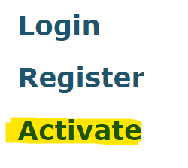

- You will be asked to input your Surname, National Insurance Number, Date of Birth and the Activation Code contained in your letter.

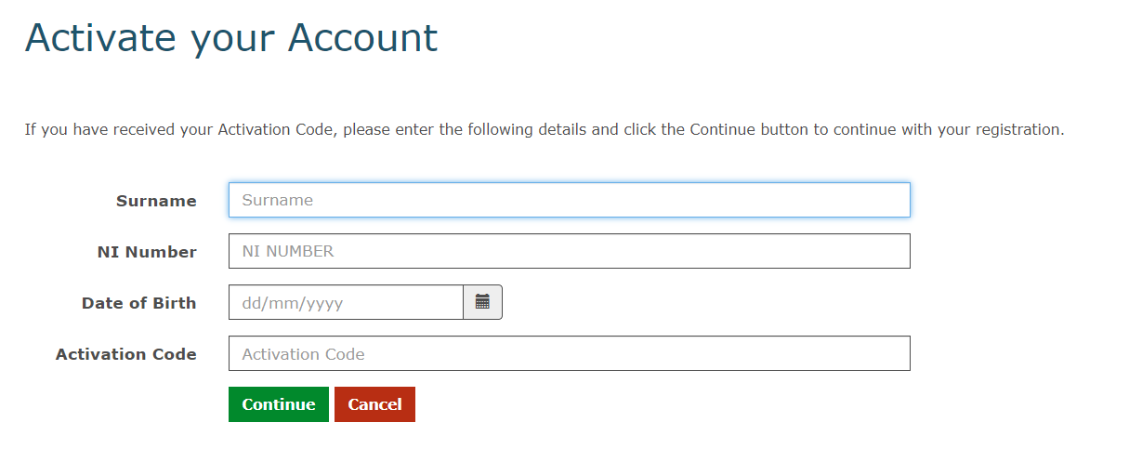

- Click to create your Username and Password and select a unique Security
Question. Please see the previous page for details.

If you would like help accessing your online account a member of the pension team will be more than happy to go through this with you and provide assistance.
Please contact the pension team on 01628 796 668 or e-mail info@berkshirepensions.org.uk

