Royal County of Berkshire Pension Fund
Welcome to the Local Government Pension Scheme

The Local Government Pension Scheme (LGPS) is a very important benefit. Not only will it provide you with an income in retirement, payable for life, but it also gives your loved ones financial security in the event of your death or long-term ill-health.

What type of scheme is the LGPS?
The LGPS is a registered pension scheme and is known as a Defined Benefit pension scheme. The benefits you build up are based on a Career Average Revalued Earnings (CARE) basis. It is a very secure scheme because the benefits are set out in law. This means that the pension you earn each year is based on your actual pensionable pay received in each scheme year (1 April to 31 March) and not on the contributions you pay as with ‘money-purchase’ pension schemes.

You will be admitted to the Scheme automatically from your first day of employment, although if you work for a town or parish council, or certain admitted bodies that participate in the Scheme, you may need to be designated by your employer as being eligible to join.

Once you are a member you can opt out of the Scheme at any time but once you have 2 years qualifying membership or, you have previous pension rights held with the LGPS you will not be able to claim a refund of the contributions you have paid. Instead you will be entitled to a pension benefit at retirement.

How much does it cost?
The amount you pay into the Scheme will be assessed by your employer in line with the table below and in accordance with your earnings. These salary bands will change from time to time in line with inflation but the rates shown here are valid from 1 April 2024 to 31 March 2025. Your employer also makes a contribution to the Scheme. The rate that your employer pays is set every three years in-line with an actuary’s valuation of the Fund.

The 50/50 section
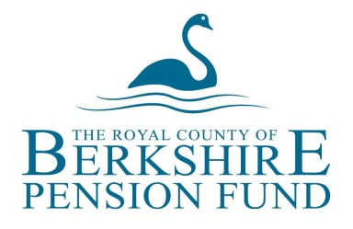
There are two sections of the Local Government Pension Scheme (LGPS) the MAIN section and the 50/50 section. Under the MAIN section of the Scheme you pay your normal contribution rate to get the normal pension build up. Under the 50/50 section you pay half your normal pension contribution and get half the pension build up in return. Entry into the 50/50 section of the LGPS is designed to be a short-term option for when times are difficult financially.

If you are in the 50/50 section your employer is required to re-enrol you back into the MAIN section of the Scheme every three years. This will be carried out in line with your employer’s automatic re-enrolment date. You will also be entered back into the MAIN section if you have a period of long-term sickness where you go into unpaid sickness absence.

Employee Contribution Table 2024/2025
Banding | Annual Salary Range | MAIN Section | 50/50 Section
1 | Up to £17,600 | 5.5% | 2.75%
2 | £17,601 to £27,600 | 5.8% | 2.9%
3 | £27,601 to £44,900 | 6.5% | 3.25%
4 | £44,901 to £56,800 | 6.8% | 3.4%
5 | £56,801 to £79,700 | 8.5% | 4.25%
6 | £79,701 to £112,900 | 9.9% | 4.95%
7 | £112,901 to £133,100 | 10.5% | 5.25%
8 | £133,101 to £199,700 | 11.4% | 5.7%
9 | £199,701 or more | 12.5% | 6.25%

Transferring former pension rights
You can transfer former pension rights into the LGPS from previous schemes in which you have been a member. You MUST apply to transfer any former benefits into the LGPS within 12 months of joining the Scheme, although your employer can extend this period at their discretion. There are also options available to you to pay more contributions in order to increase your income in retirement. Further information on both of these issues can be found on our website.

When can I claim my pension?
You can retire and receive your LGPS benefits from your Normal Pension Age (NPA) which is equal to your State Pension Age (SPA) with a minimum age of 65. Benefits can be paid earlier from the age of 55, although this may result in your benefits being reduced to reflect their early payment.

If you have to leave your employment early because of ill-health and you have more than two years LGPS membership you can apply to your employer for the release of your pension on ill-health retirement grounds. In some cases an enhancement is applied to reflect the fact that you have had to retire before your NPA.

Benefits are even paid early if you are made redundant by your employer, providing you are at least two years membership and are aged 55 or over at the time.

Protection for your family
From your very first day of Scheme membership, should you die in service, a death grant equal to three times your assumed annual pensionable pay is due from the Scheme. In addition, benefits also become payable to your dependants. This is a very valuable benefit because if the worst happens, you know that your loved ones will be looked after. Your dependants include your husband or wife, your co-habiting partner or registered civil partner and your eligible children. Further details are available from our website.

Calculating your pension
Each year 1/49th of your pensionable pay is put into your pension account. At the end of the year it is adjusted by the Consumer Prices Index (CPI) to take into account the cost of living. The next year the same thing happens again and so on.

CARE Scheme formula = Actual Pensionable Pay X 1/49th = Annual Pension

CARE Scheme example

A member earns £24,500 in 2023/2024.

Based on the build up rate of 1/49th their annual pension will be calculated as
follows: £24,500/49 = £500.00

Assuming that CPI is 3% this annual pension amount will be increased as follows:
£500 + 3% = £515 This pension will then be increased by CPI every subsequent
year.

If you have previous LGPS membership built up before 1 April 2014, your benefits will be calculated differently. These will have built up on a 1/80th basis with an automatic lump sum whereas benefits built up from 1 April 2008 provide a higher, 1/60th rate of pension with no automatic lump sum. Even so, current Scheme regulations do permit you to buy some tax-free cash by exchanging some of your annual pension at a conversion rate of 12 to 1 i.e. for every £1 of pension you give up, you can buy £12 of tax-free cash subject to HM Revenue & Customs limits.

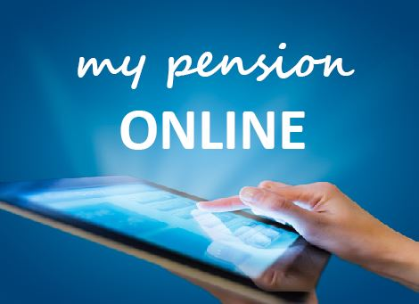
‘my pension ONLINE’
Don’t forget you can now view your pension information online through our online service - ‘my pension ONLINE’.
‘my pension ONLINE’ enables you to securely update your personal details, perform benefit calculations and update your nominated beneficiaries from the comfort of your own home or workplace.
It’s easy to sign up - just visit our website and click on the ‘my pension ONLINE’ logo.

More information

More detailed information about the LGPS is available from the pension team at the following address: Royal County of Berkshire Pension Fund, Minster Court, 22-30 York Road, Maidenhead, Berkshire, SL6 1SF

Tel: 01628 796 668

E-mail: info@berkshirepensions.org.uk
Web: www.berkshirepensions.org.uk

