Royal County of Berkshire Pension Fund
Flexible Retirement Guide

Your employer can use a discretion to allow you to receive all or part of your retirement built up to date whilst remaining in the pension scheme and continuing in employment at a reduced grade or with reduced hours of work, thereby avoiding the need to work full-time until you reach your Normal Pension Age (NPA) – this is known as ‘flexible retirement’.

When can I apply for flexible retirement?

Flexible retirement is open to members who are:

- age 55 or over at the point you flexible retire and
- have been a member of the LGPS for at least two years
In order to trigger the release of your pension in this way the LGPS regulations also state you must either:
- reduce your hours of employment or
- reduce your grade

Who do I apply to for flexible retirement?

Flexible retirement is an employer discretion under the LGPS regulations.

Your employer must include in their policy statement, details as to how they intend to use this discretion available to them under the LGPS regulations.

In the first instance we recommend you speak with your employer directly who will investigate your enquiry further.

How many hours do I need to reduce to qualify?

The LGPS regulations do not state a specific number of hours or the grade you have to reduce to. However, this will be at the discretion of your employer so please speak to them directly.

Will my pension be reduced if I take flexible retirement?

If you flexibly retire your pension will normally be reduced if you are under your NPA.

However, your employer may determine to waive all, or part of any reduction applied.
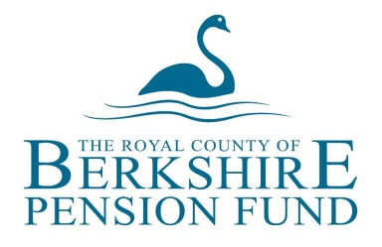
Please speak with your employer directly regarding their policy on this.

Can I still contribute to the LGPS once I have flexibly retired?

Yes, once you have flexibly retired you remain in the pension scheme in respect of your ongoing employment. As a result you will build up a second pension account within the LGPS. When you retire completely in the future your second pension will be added to your flexible retirement pension amount.

Will I have the option of taking a lump sum at the point I flexibly retire?

Yes, if you take flexible retirement you can choose to exchange some annual pension into a tax-free lump sum.

For every £1 of annual pension you give up you will receive £12 of tax-free lump sum.
If you joined the L G P S before 1 April 2008 then you will receive a tax-free lump sum when you retire. You will also have the option to exchange part of your pension to increase your lump sum.

The lump sum retirement grant is a tax-free one-off payment.

What happens to my Additional Voluntary Contributions (AVCs) if I take flexible retirement?

If you have an AVC fund with the Prudential, you will be entitled to take your AVC at the point you flexibly retire. We would provide you with your AVC options when we write to you regarding your flexible retirement.

Will I have to pay tax on my flexible retirement pension?

Your annual pension is classed as a taxable income. When we commence payment of your flexible retirement pension, we will inform HMRC accordingly. HMRC will notify us of the tax code they wish to operate for you. Any tax that you have to pay will be deducted at source from your monthly pension payments.

Do I have to give notice to claim my flexible retirement pension?
No, your employer’s payroll department will notify us of your flexible retirement details. Once the formal instruction has been received from payroll we will contact you directly with to confirm your retirement options.

How do I obtain a flexible retirement quotation?
If you would like an estimate of your pension entitlement assuming you were to be granted flexible retirement, please contact your employer directly. We are unable to provide flexible retirement figures directly to scheme members, but your employer can request such an estimate on your behalf.

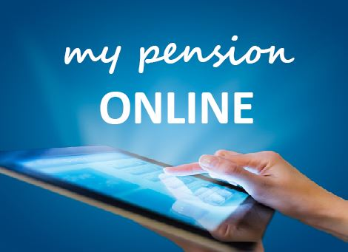
‘my pension ONLINE’
Don’t forget you can now view your pension information online through our online service - ‘my pension ONLINE’.
‘my pension ONLINE’ enables you to securely update your personal details, perform benefit calculations and update your nominated beneficiaries from the comfort of your own home or workplace.
It’s easy to sign up - just visit our website and click on the ‘my pension ONLINE’ logo.

More information

More detailed information about the scheme is available from the pension team at the following address: Royal County of Berkshire Pension Fund, Minster Court, 22-30 York Road, Maidenhead, Berkshire, SL6 1SF
Tel: 01628 796 668
E-mail: info@berkshirepensions.org.uk
Web: www.berkshirepensions.org.uk

